HOW TO MAKE A LINKEDIN ACCOUNT IN 9 EASY STEPS

- Go to LinkedIn’s website.

- Click join now.
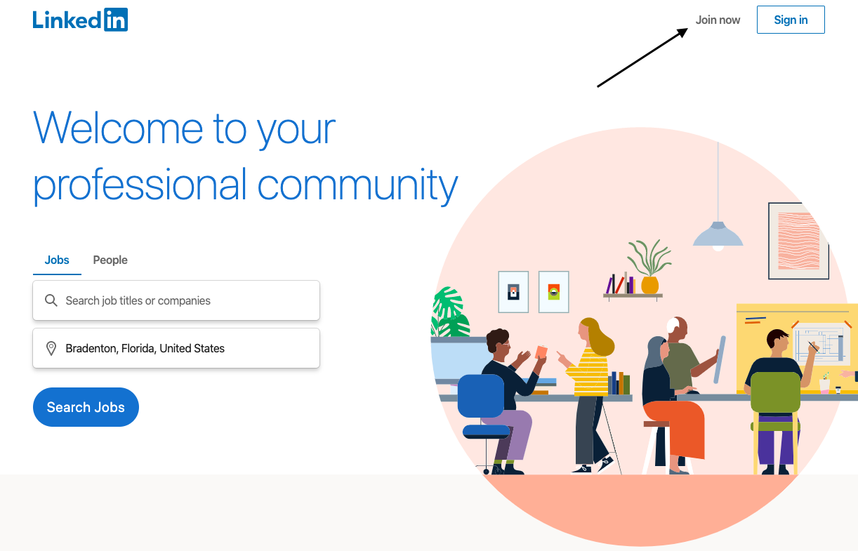
- Enter your email and create password.

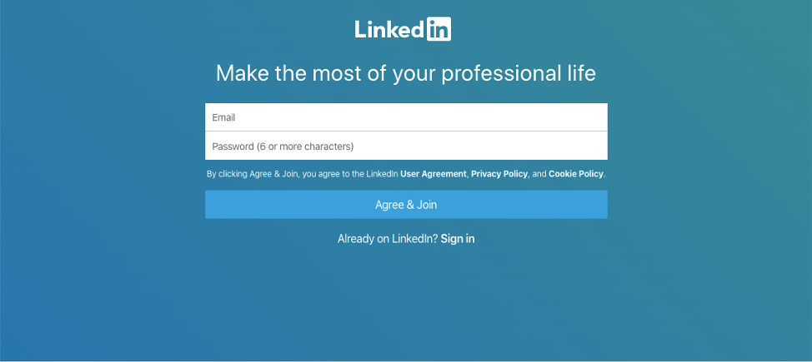
- Enter your first and last name.
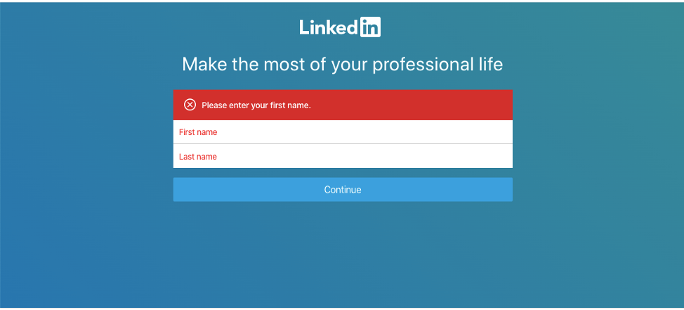
- Enter your current location.
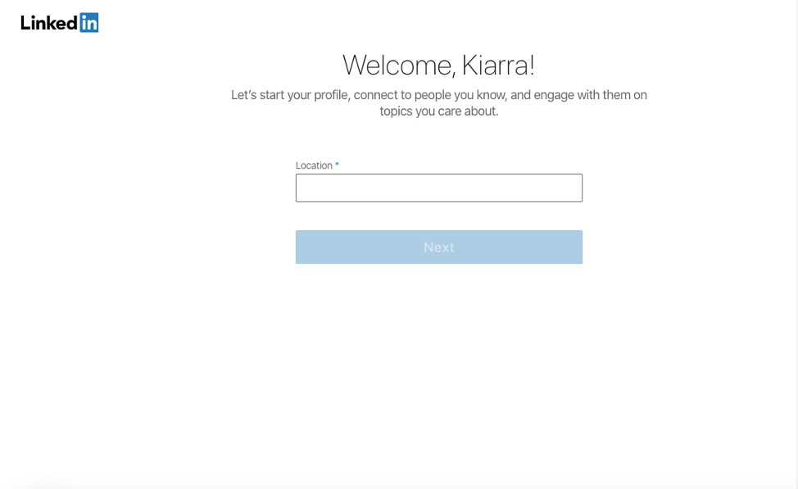
- Click on “I’m a student”. Note: If you are not a student, enter your most recent company and most recent job title.
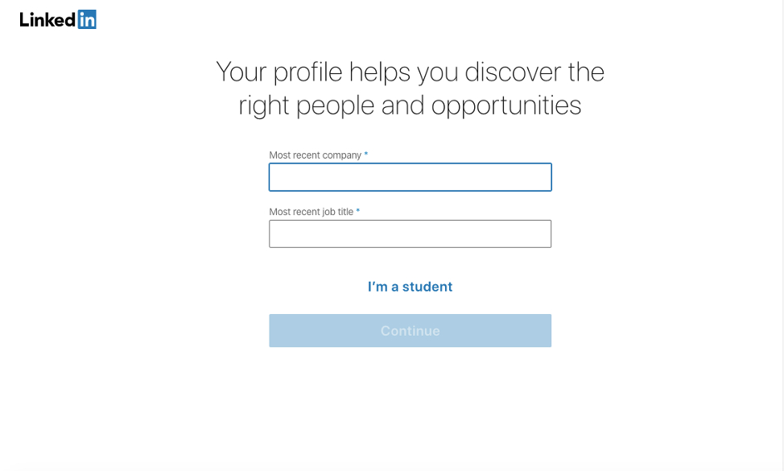
- Enter your school/college university, degree, specialization, start year, end, year and toggle whether you are over 16 or not.
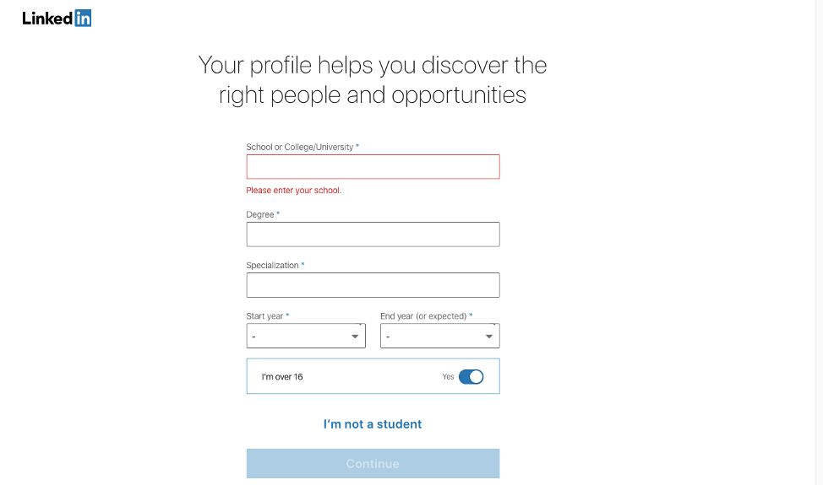
- Confirm your email. Note: Go to your email to receive the code you were sent then enter
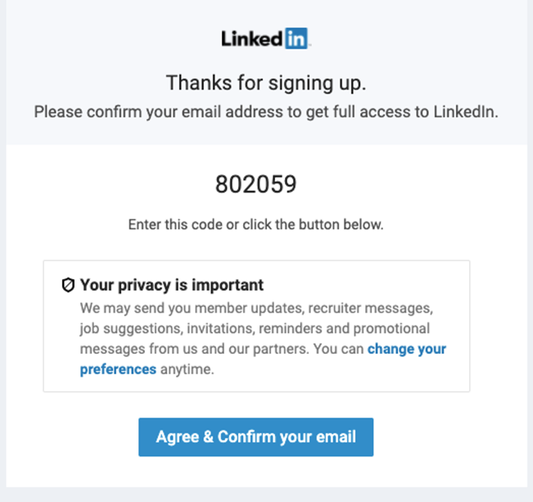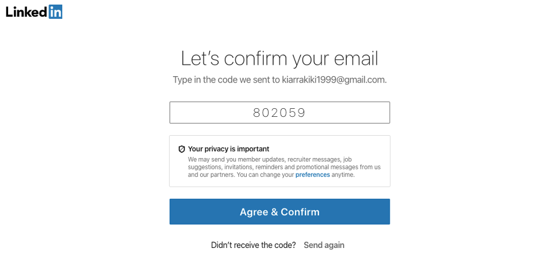

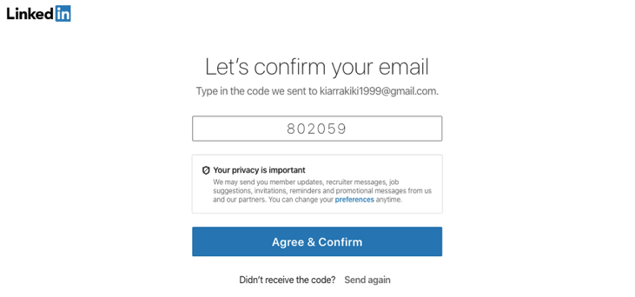

- Enter the job you are interested in and in what location.
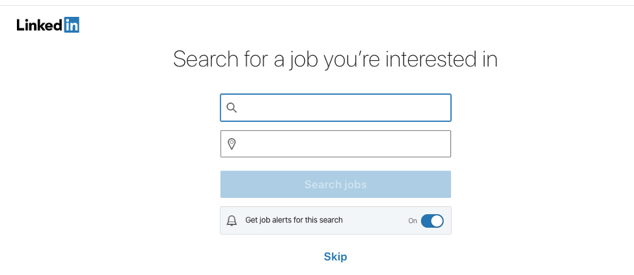

CONGRATULATIONS, YOU NOW HAVE A LINKEDIN ACCOUNT. TO LEARN HOW TO USE IT, CLICK HERE.

